DEPARTMENT OF ELECTRICAL AND ELECTRONIC ENGINEERING
UNIVERSITY OF BENIN, BENIN CITY

EXPERIMENT 209-3

TITLE
Three-Phase AC Circuits

AIM
The aim of this experiment is to verify the relationships between phase and line voltages and currents in a three-phase balanced system, and to measure power in three-phase systems by the one-wattmeter method and the two-wattmeter method.

OBJECTIVES
- To measure the line and phase voltages of a balanced star-connected load and show that the line voltage is √3 times the phase voltage.
- To show that the line current is equal to the phase current in a star connection, and that the neutral current is zero when the load is balanced.
- To measure the power of a balanced load using one wattmeter.
- To measure the power of an unbalanced load using two wattmeters, and to find the neutral current from a phasor diagram.

APPARATUS
- 400 V, 50 Hz, 3-phase supply (1)
- 3-phase variable autotransformer (variac) (1)
- 3-phase variable resistive load, resistance bank (1)
- Voltmeter, 0 – 300/600 V AC, with selector switch (1)
- Ammeters, 0 – 5 A AC (4)
- Wattmeters, 5 A, 300 V (2), and two-way switch S1 (1)
Note: The one-wattmeter method works only when the load is balanced, because the same reading pattern is assumed in all three phases. The two-wattmeter method does not need the load to be balanced, but it is exact only when no current flows in the neutral wire. Throughout this experiment, all connections were checked by a supervisor before power was switched on.

THEORY
A three-phase supply has three voltages of equal size that are 120° apart in time. In a star connection, one end of each of the three coils is joined at a common point called the neutral point (N), and the other ends are connected to the lines R (red), Y (yellow) and B (blue). The voltage between a line and the neutral is called the phase voltage (Vp), and the voltage between any two lines is called the line voltage (VL). The phase sequence used in this experiment is R-Y-B.
When the load is balanced, all three phases take the same current. In this case the line voltage is √3 times the phase voltage, the line current is equal to the phase current, and the three currents cancel each other at the star point, so the neutral wire carries no current:
VL = √3 × Vp IL = Ip IN = 0
The power taken by a three-phase load is the sum of the powers in its three phases. For a balanced load with power factor cos φ, this is P = 3 Vp Ip cos φ = √3 VL IL cos φ. For a purely resistive load, cos φ = 1. For an unbalanced load, the power of each phase must be found separately and added:
P = IR VRN + IY VYN + IB VBN
In the one-wattmeter method, the current coil of the wattmeter is placed in line R, and the pressure coil is joined to line R at one end and, through the switch S1, to line Y (position 1) or line B (position 2) at the other end. The two readings are W1 = VL IL cos (30° + φ) and W2 = VL IL cos (30° − φ). Their sum gives the total power:
W1 + W2 = √3 VL IL cos φ
In the two-wattmeter method, the current coils of two wattmeters are placed in two lines (R and Y here), and their pressure coils are joined to the third line (B), which is the common line. The total power is the algebraic sum of the two readings, P = W1 + W2. For a balanced load, the readings are W1 = VL IL cos (30° − φ) and W2 = VL IL cos (30° + φ), and the power factor can be found from tan φ = √3 (W1 − W2) / (W1 + W2). The method is exact for a three-wire system. If the neutral wire carries current, the sum of the two readings differs from the true power, because part of the power is then taken through the neutral path.
When the load is unbalanced, the three line currents no longer cancel. The difference flows back through the neutral wire, so IN = IR + IY + IB (phasor sum). Because the neutral wire holds the star point at the supply neutral, the three phase voltages stay almost equal even though the currents are different.
The multiplication factor of a wattmeter is found from: (voltage range × current range × power factor) / full-scale divisions. For the 300 V, 5 A, unity power factor wattmeter with 150 divisions, this is (300 × 5 × 1) / 150 = 10 W per division.

DIAGRAM
(a) Balanced system
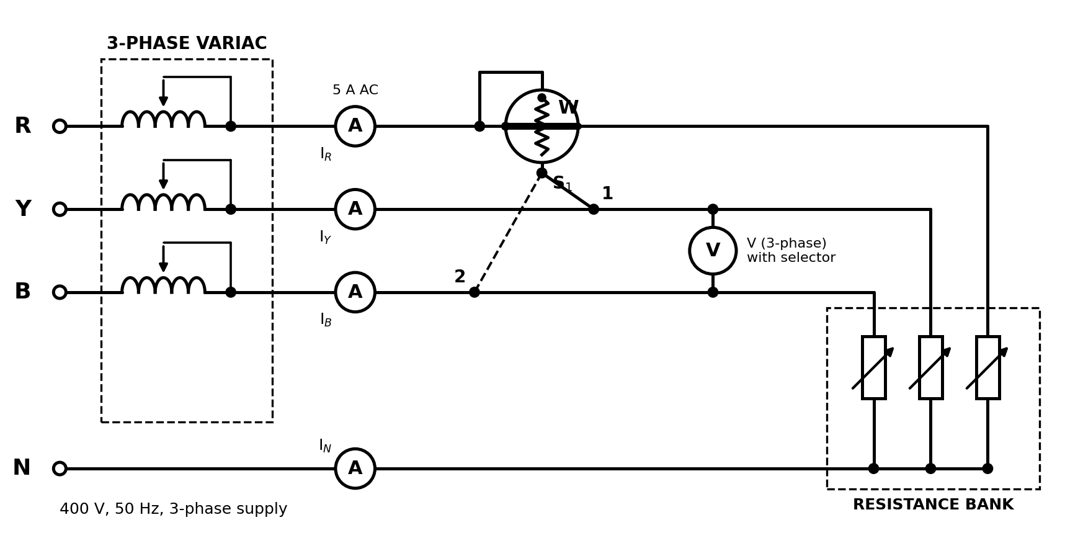
Figure 1: Connection for the balanced system (one-wattmeter method)
(b) Unbalanced system
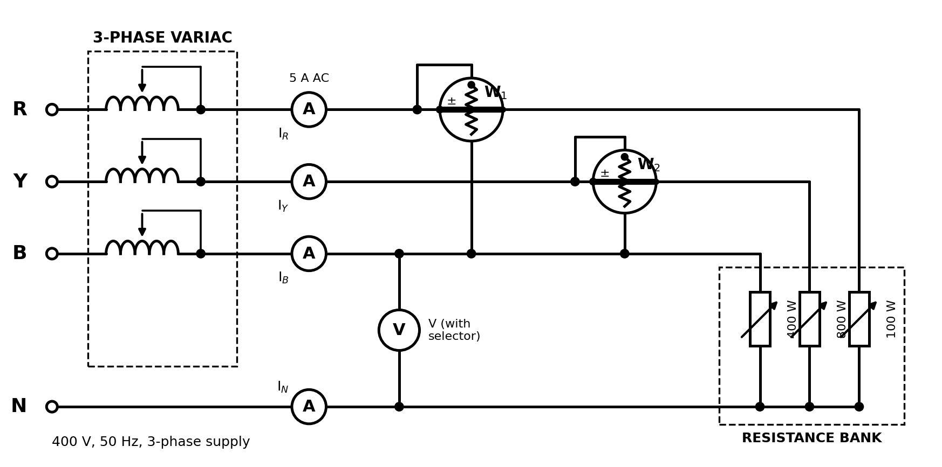
Figure 2: Connection for the unbalanced system (two-wattmeter method)

PROCEDURE
A. Balanced system
- Make the connections as shown in Figure 1.
- Adjust the line voltage to 300 V with the variac. Check that the load is balanced and in the 300 W per phase position, then close the load switches.
- Measure the three line voltages, the three line-to-neutral voltages, the three line currents and the neutral current.
- Read the wattmeter with the switch S1 in position 1, then with S1 in position 2. Record all readings in Tables 209-1, 209-2 and 209-3.
B. Unbalanced system
- Make the connections as shown in Figure 2.
- Set the resistors in the bank as follows: red phase 100 W, yellow phase 800 W and blue phase 400 W.
- Measure the line voltages, line-to-neutral voltages, line currents and neutral current, and record them in Tables 209-4 and 209-5.
- Read wattmeters W1 and W2 and record the readings in Table 209-6. Switch off the supply and reduce the load to zero.

OBSERVATION
Wattmeter: 300 V, 5 A, 150 divisions, multiplication factor = 10 W per division. Phase sequence R-Y-B.
A. Balanced system
Table 209-1: Voltages, balanced system (volts)
VRY | VYB | VBR | Ave. line volt | VRN | VYN | VBN | Ave. phase volt | Line volt / Phase volt
300 | 301 | 299 | 300 | 173 | 174 | 172 | 173 | 1.734
The line voltage is about 1.73 times the phase voltage, which agrees with the theory VL = √3 Vp.
Table 209-2: Currents, balanced system (amperes)
IR | IY | IB | IN | Average line current
1.74 | 1.72 | 1.73 | 0.02 | 1.73
The three line currents are almost equal and the neutral current is nearly zero, as expected for a balanced load.
Table 209-3: Wattmeter readings, one-wattmeter method
Position of switch S1 | Scale reading (div.) | Multiplication factor | Sign | Power reading (W)
Position 1 | 45.0 | 10 | + | 450
Position 2 | 44.5 | 10 | + | 445
Algebraic sum |  |  |  | 895
Sample calculation: Line voltage / phase voltage = 300 / 173 = 1.734 ≈ √3. Total power received by the load = IR VRN + IY VYN + IB VBN = (1.74 × 173) + (1.72 × 174) + (1.73 × 172) = 301.0 + 299.3 + 297.6 = 897.9 ≈ 898 W. Algebraic sum of the wattmeter readings = 450 + 445 = 895 W. The difference is 3 W, which is (3 / 898) × 100 = 0.33 %. Both positions of S1 give almost the same reading because the load is resistive and balanced (φ = 0, so each reading is VL IL cos 30°).
B. Unbalanced system
Table 209-4: Voltages, unbalanced system (volts)
VRY | VYB | VBR | VRN | VYN | VBN
300 | 299 | 301 | 174 | 172 | 173
Table 209-5: Currents, unbalanced system (amperes)
IR | IY | IB | IN
0.57 | 4.64 | 2.33 | 3.50
The phase voltages stay almost equal, but the currents are very different. A large current of 3.5 A flows in the neutral wire.
Table 209-6: Wattmeter readings, two-wattmeter method
Meter | Scale reading (div.) | Multiplication factor | Power in watts | Sign
Wattmeter W1 | 15.5 | 10 | 155 | +
Wattmeter W2 | 119.5 | 10 | 1195 | +
Sample calculation: Algebraic sum of the wattmeter readings = 155 + 1195 = 1350 W. Total power received by the load = IR VRN + IY VYN + IB VBN = (0.57 × 174) + (4.64 × 172) + (2.33 × 173) = 99.2 + 798.1 + 403.1 = 1300.4 ≈ 1300 W, which agrees with the set values of the bank (100 + 800 + 400 = 1300 W). The difference is 50 W, which is (50 / 1300) × 100 = 3.8 %. This small difference exists because the neutral wire carries current (3.5 A), and the two-wattmeter method is exact only when there is no neutral current.

GRAPH
Graph 1 shows the phasor diagrams drawn to scale from Tables 209-4 and 209-5. The voltage scale is 1 cm = 50 V and the current scale is 1 cm = 1 A. Phase sequence R-Y-B is used, and each current is drawn in phase with its phase voltage because the load is resistive.
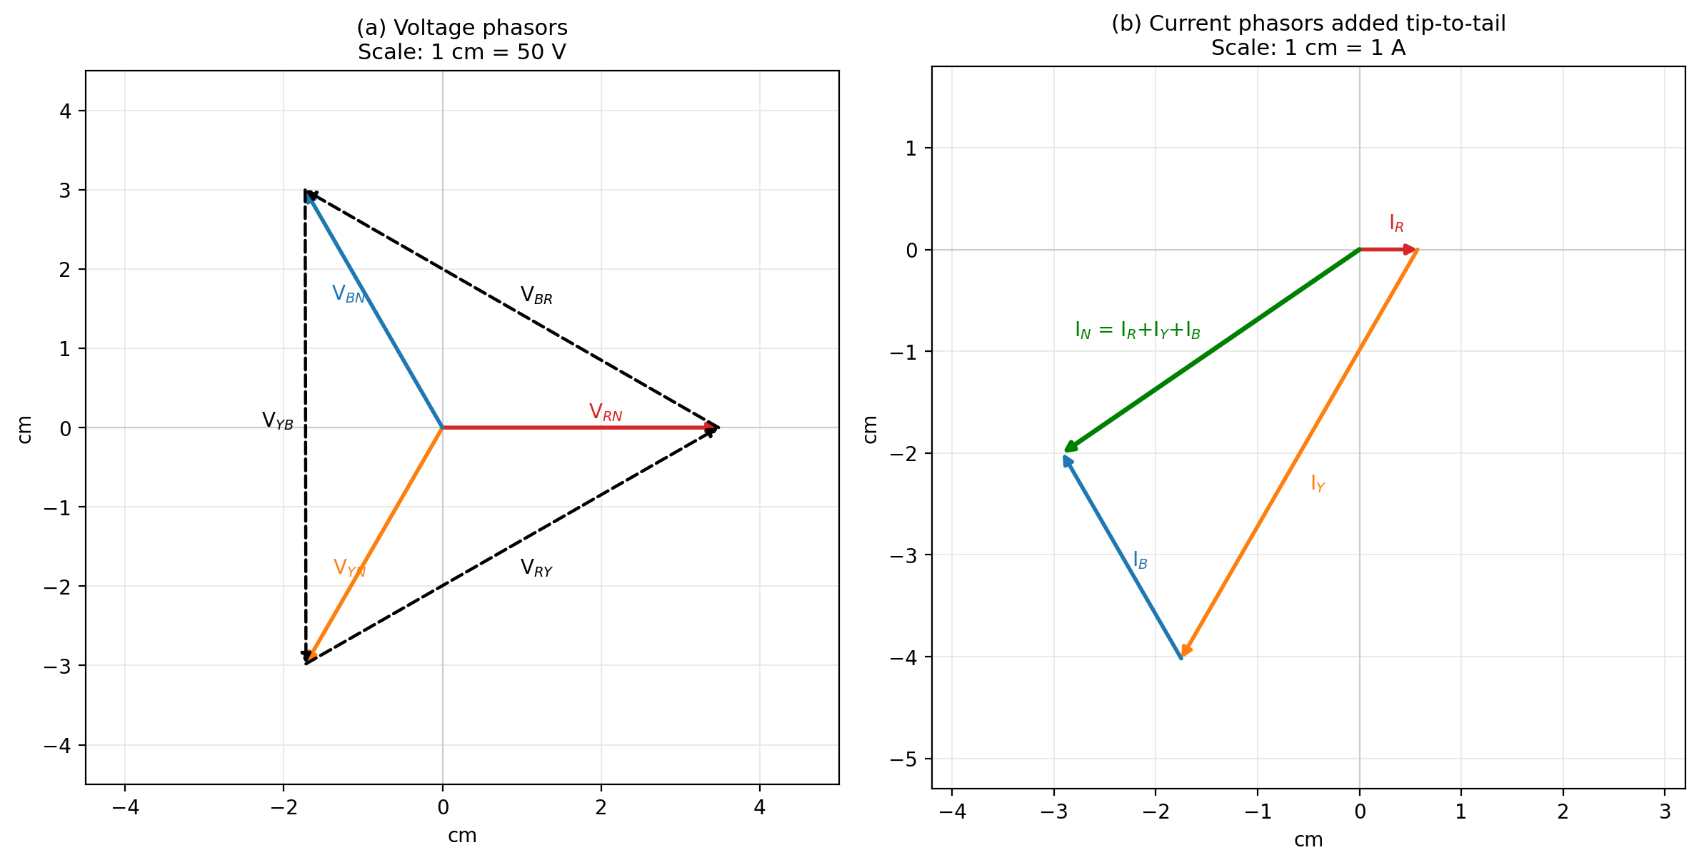
Graph 1: Phasor diagrams of voltages and currents, unbalanced system
When the three line currents are added tip to tail, the resultant is 3.54 A (about 3.5 A). This agrees with the neutral current of 3.50 A read on the ammeter.
Graph 2 shows the phasor diagram used to prove the two-wattmeter method for a balanced load.
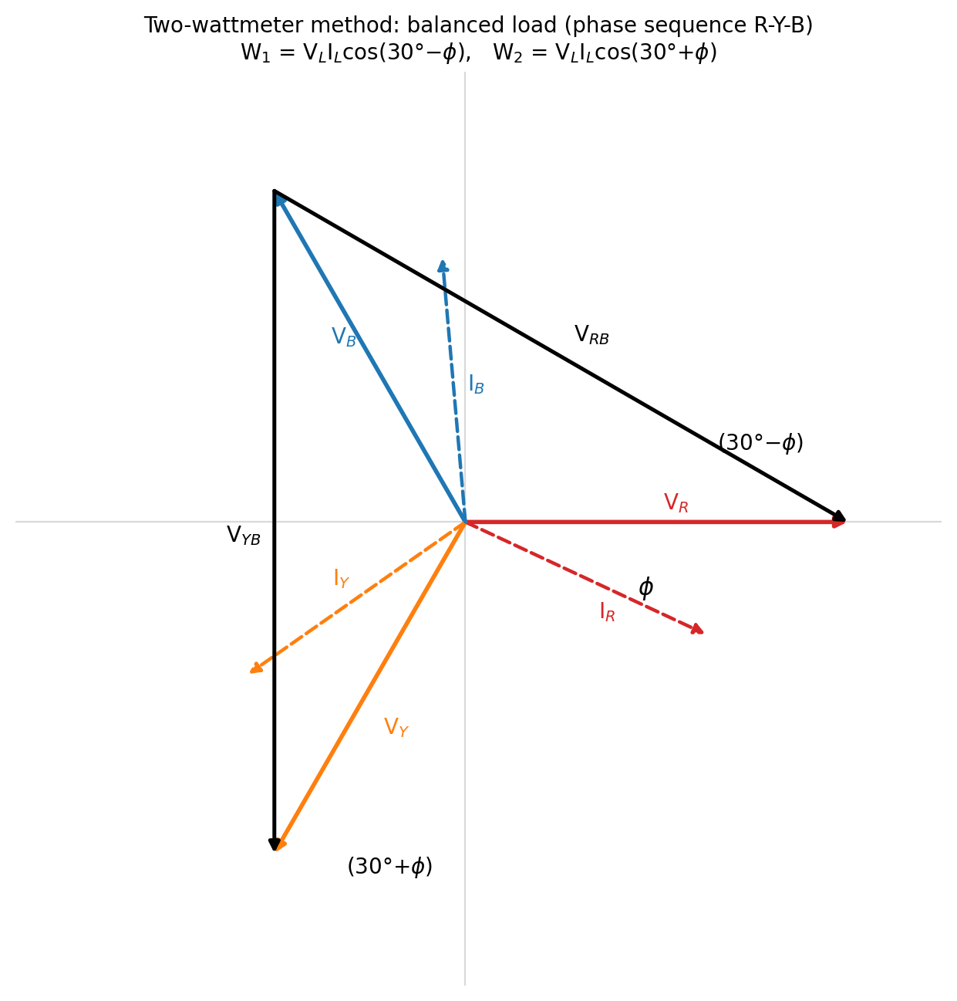
Graph 2: Phasor diagram for the two-wattmeter method (balanced load)

ANSWERS TO QUESTIONS
Question 1: Phasor diagram for the unbalanced resistive load
Method of construction:
- Choose scales: 1 cm = 50 V for voltages and 1 cm = 1 A for currents.
- Draw VRN (3.48 cm) as the reference phasor along the horizontal line. Draw VYN (3.44 cm) at 120° behind it and VBN (3.46 cm) at 120° ahead of it, for phase sequence R-Y-B.
- Join the tips of the phase voltages to get the line voltages VRY, VYB and VBR (about 6 cm each, that is 300 V).
- The load is resistive, so each current lies along its own phase voltage: IR = 0.57 cm, IY = 4.64 cm and IB = 2.33 cm.
- Add the three currents tip to tail. The line joining the start to the end is the sum of the line currents.
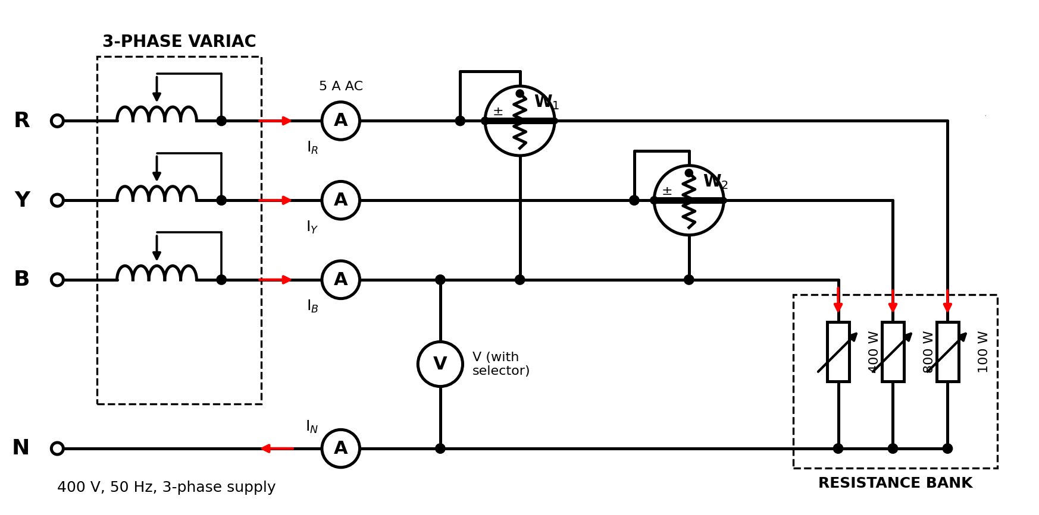
Figure 3: Circuit for Question 1, with current directions and polarity marks
Verification: the sum of the three line currents is 3.54 A, which equals the current returning through the neutral wire (3.50 A measured). By Kirchhoff’s current law at the star point, IR + IY + IB − IN = 0. The line currents add up to zero on their own only when the neutral current is zero (a balanced load, or a three-wire system without a neutral wire).
Question 2: Two-wattmeter method for a balanced system
Graph 2 shows a balanced system with the current lagging the phase voltage by angle φ. Line B is the common line.
- Wattmeter W1 carries IR and its pressure coil reads VRB. The angle between VRB and IR is (30° − φ), so W1 = VL IL cos (30° − φ).
- Wattmeter W2 carries IY and its pressure coil reads VYB. The angle between VYB and IY is (30° + φ), so W2 = VL IL cos (30° + φ).
Adding the two readings:
W1 + W2 = VL IL [cos (30° − φ) + cos (30° + φ)] = 2 VL IL cos 30° cos φ = √3 VL IL cos φ
This is the total power of a balanced three-phase load, so the two-wattmeter method can be used to measure power in a balanced three-phase system.

PRECAUTIONS
- All connections were checked by a supervisor before the power supply was switched on, as required throughout this experiment.
- The variac was set to zero before starting, and the voltage was raised gradually to 300 V.
- The load was checked to be balanced and in the correct position before the load switches were closed.
- The meter ranges were checked to make sure they were not exceeded at any stage, especially the 5 A ammeters and wattmeters.
- Care was taken to connect the current and pressure coils of the wattmeters with the correct polarity, to avoid a backward reading.
- All meters were read with the eye directly in front of the pointer to avoid parallax error.
- All equipment was switched off immediately after each part of the experiment was completed.

CONCLUSION
This experiment showed that, in a balanced star-connected system, the line voltage is √3 times the phase voltage (300 V against 173 V, a ratio of 1.734), the line current equals the phase current (about 1.73 A), and the neutral current is almost zero. The one-wattmeter method gave 895 W against a calculated load power of 898 W, a difference of only 0.33 %.
It also showed that, in an unbalanced system, the line currents are different (0.57 A, 4.64 A and 2.33 A) and a current of 3.5 A flows in the neutral wire, which was confirmed by the phasor diagram. The two wattmeters read a total of 1350 W against a load power of 1300 W. The 3.8 % difference is mainly because the neutral wire carried current, since the two-wattmeter method is exact only when there is no neutral current. Overall, the experiment confirmed the theory of three-phase star-connected circuits and the methods of measuring three-phase power.

